MECH 320-Mechanics of Materials
AMERICAN UNIVERSITY OF BEIRUT

STUDENT NAME:

ID:

Final Exam
May 15, 2013
Spring semester 2012-2013
Instructor: Mutasem Shehadeh, Amer El Souri
Two Hours

Problem 1: 15 pts
For each of the plane stress states below, draw a Mohr’s circle diagram properly labeled, find the
Principal normal stresses, the maximum in-plane shear stress, and the absolute maximum shear stress
a) σ_{x}= 12 MPa, σ_{y}= 6 MPa, τ_{xy}= 4 MPa cw (clockwise)
b) σ_{x}= 6 MPa, σ_{y}= -5 MPa, τ_{xy}=8 MPa ccw (counter clockwise)

Problem 2: 15 pts
The equilibrium equations for a deformable body in 2D problem can be written as
For the cantilever beam of a rectangular cross sectional area A = b×h, a length L, and a tip force P shown below, prove that at any random location m(x,y) the equilibrium equations are satisfied.
y
P

. m(x,y)
h
x

b
L

Problem 3: 20 pts
The wooden T-Beam shown in the figure below is made from 200mm×30 mm boards. If the allowable bending stress σ _{all} is 12 MPa and the allowable shear stress τ _{all} is 0.8 MPa, determine if the beam can safely support the loading shown. Also, specify the maximum spacing of nails needed to hold the two boards together if each nail can safely resist 1. 5 kN in shear.
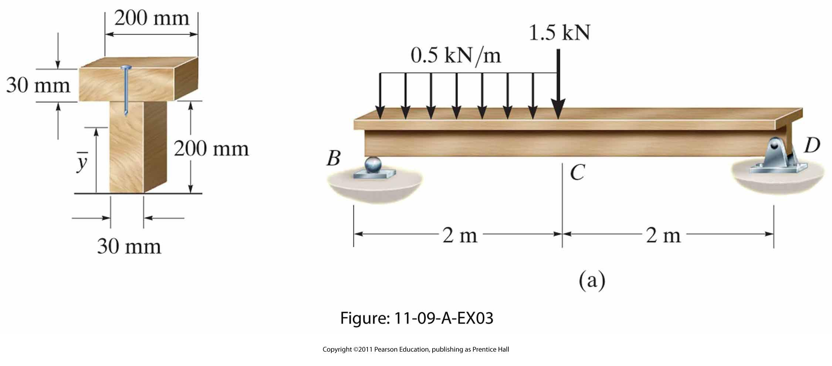

Problem 4: 20 pts
The drill pipe shown in the figure below is designed as a hollow shaft with an outer diameter of 80mm, inner diameter of 70 mm , weight of 800 N/m and a length of 12 m. The pipe is made of steel alloy with a modulus of elasticity of 200 GPa. If the pipe is subjected to an axial load P of 7500 N and it is turning at a speed of 60 rev/min driven by a 7500 Watt diesel engine, determine the following:
- The average bearing stress.
- The shear stress induced due to the torque on the outer surface of the pipe.
- The normal compressive stress developed at section a-a located at half the pipe’s length.
P
T
6m
6m
a
a

Problem 5: 30 pts
The figure below shows a 24 mm diameter rod fixed at O and loaded by F= 550 N which causes twisting and bending. Neglect the effect of stress concentrations.
- Plot the moment and shear diagrams for OA
- Plot the torque diagram for OA
- Determine the state of stress at point I located on the upper surface of the 24 mm rod (show the results on a differential element)
- Determine the principal stresses, and the maximum in plane and the absolute maximum shear stresses at point I.
- Draw Mohr’s circle for the state of stress at I and find the orientation of the element in the principal directions.
- Determine the angle of twist at point A

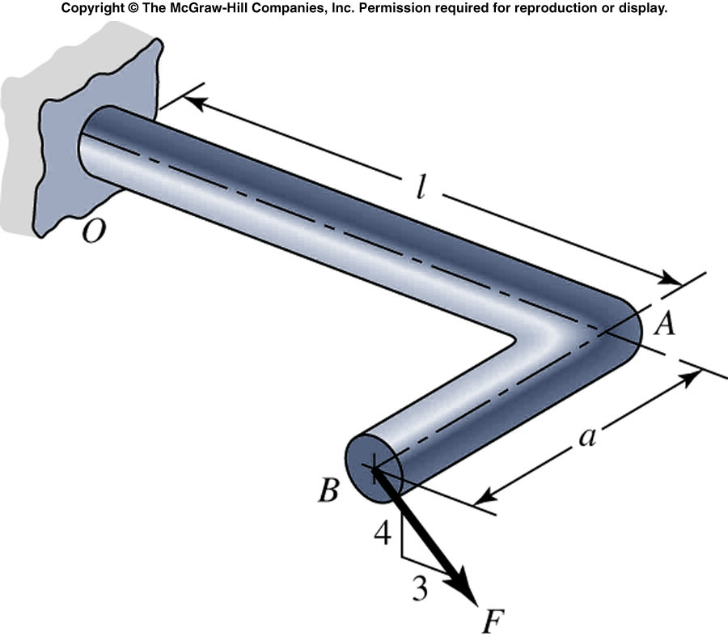
I
1.5 m

0.5 m

